**Web Api using .Net core with Swagger**

**Task:**

Create a .Net core web application with API template. (Use existing application if created). Install Swashbuckle.AspNetCore Nuget package. Post this do the following steps in [Startup.cs](http://startup.cs)

Use POSTMAN tool, to point to the local Web API that was created with Employee controller. Test the GET action method using POSTMAN.

Verify the output if the List of employees are listed in the ‘Body’ part of the GET window on POSTMAN tool.

Verify the Status on the right side of the output pane on POSTMAN tool.

Modify the Controller name in the Route attribute of the Employee controller to ‘Emp’ and check its access thru POSTMAN

**Solution:**

**Controller.cs:**

using Microsoft.AspNetCore.Mvc;

using System.Collections.Generic;

namespace YourNamespace.Controllers

{

[ApiController]

[Route("api/[controller]")]

public class ValuesController : ControllerBase

{

[HttpGet]

public ActionResult<IEnumerable<string>> Get()

{

return new string[] { "value1", "value2" };

}

[HttpGet("{id}")]

public ActionResult<string> Get(int id)

{

return $"value {id}";

}

[HttpPost]

public IActionResult Post([FromBody] string value)

{

return Ok($"Posted: {value}");

}

[HttpPut("{id}")]

public IActionResult Put(int id, [FromBody] string value)

{

return Ok($"Updated id {id} with value {value}");

}

[HttpDelete("{id}")]

public IActionResult Delete(int id)

{

return Ok($"Deleted id {id}");

}

}

}

**Program.cs:**

using Microsoft.OpenApi.Models;

var builder = WebApplication.CreateBuilder(args);

builder.Services.AddControllers();

builder.Services.AddSwaggerGen(c =>

{

c.SwaggerDoc("v1", new OpenApiInfo

{

Title = "Swagger Demo",

Version = "v1",

Description = "TBD",

TermsOfService = new Uri("https://example.com/terms"),

Contact = new OpenApiContact

{

Name = "John Doe",

Email = "john@xyzmail.com",

Url = new Uri("https://www.example.com")

},

License = new OpenApiLicense

{

Name = "License Terms",

Url = new Uri("https://www.example.com")

}

});

});

var app = builder.Build();

app.UseSwagger();

app.UseSwaggerUI(c =>

{

c.SwaggerEndpoint("/swagger/v1/swagger.json", "Swagger Demo");

});

app.UseHttpsRedirection();

app.UseAuthorization();

app.MapControllers();

app.Run();

**EmployeeController.cs:**

Before changing route

using Microsoft.AspNetCore.Mvc;

using System.Collections.Generic;

**namespace** SwaggerDemoApi.Controllers

{

[ApiController]

[Route("api/[controller]")]

**public** **class** EmployeeController : ControllerBase

{

[HttpGet]

**public** ActionResult<IEnumerable<string>> Get()

{

return new string[] { "John", "Jane", "Steve" };

}

}

}

After changing route

using Microsoft.AspNetCore.Mvc;

using System.Collections.Generic;

**namespace** SwaggerDemoApi.Controllers

{

[ApiController]

[Route("api/emp")]

**public** **class** EmployeeController : ControllerBase

{

[HttpGet]

**public** ActionResult<IEnumerable<string>> Get()

{

return new string[] { "John", "Jane", "Steve" };

}

}

}

**CLI:**

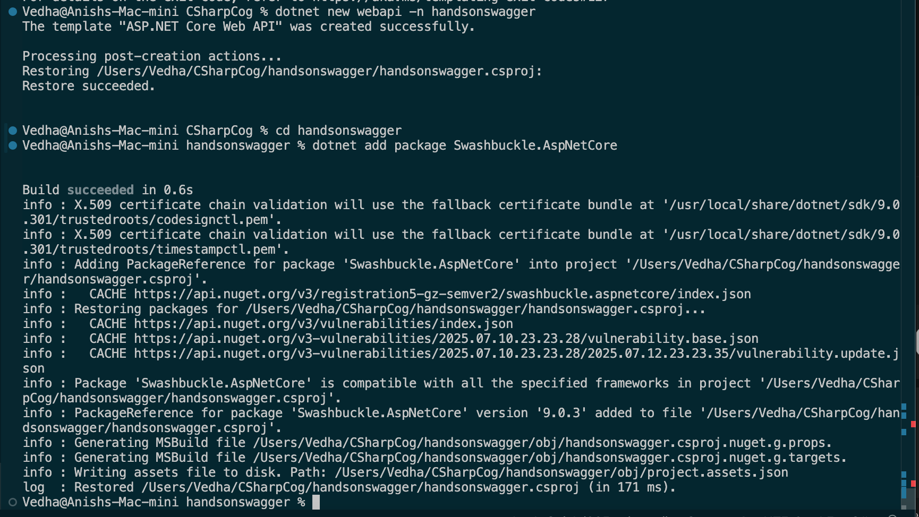

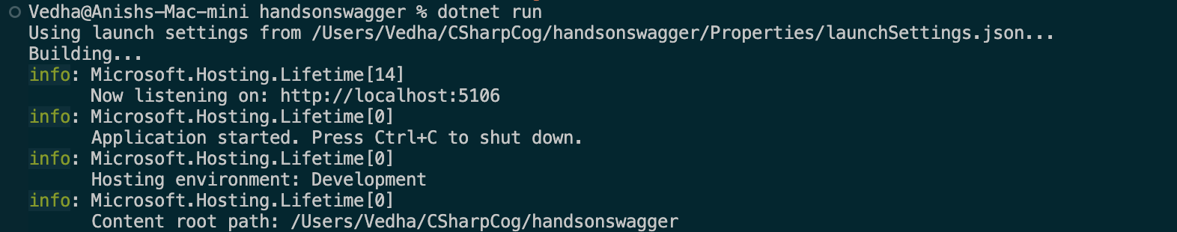

**Local Host:**

**http://localhost:5106/swagger/index.html**

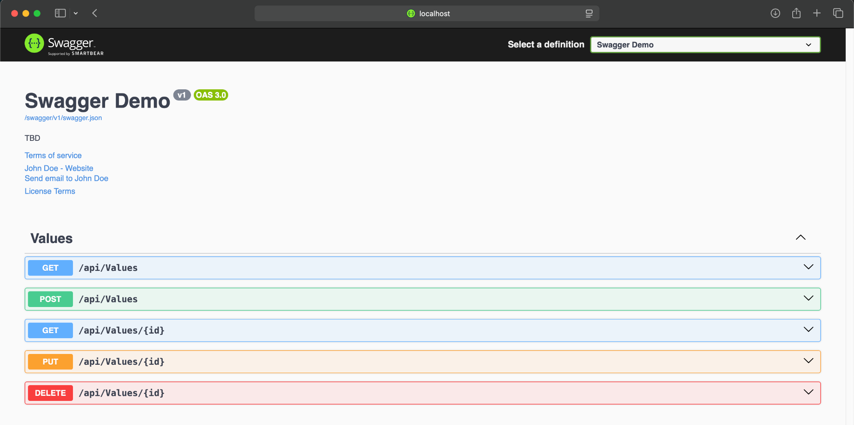

**GET- Try it out option**

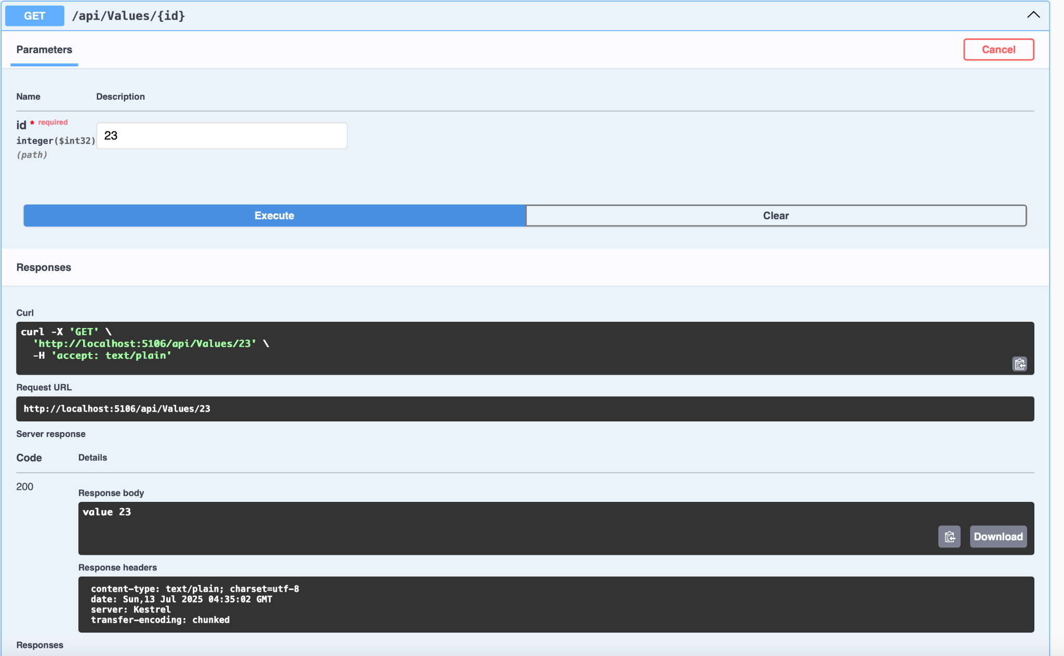

**Postman:**

**http://localhost:5106/api/employee**

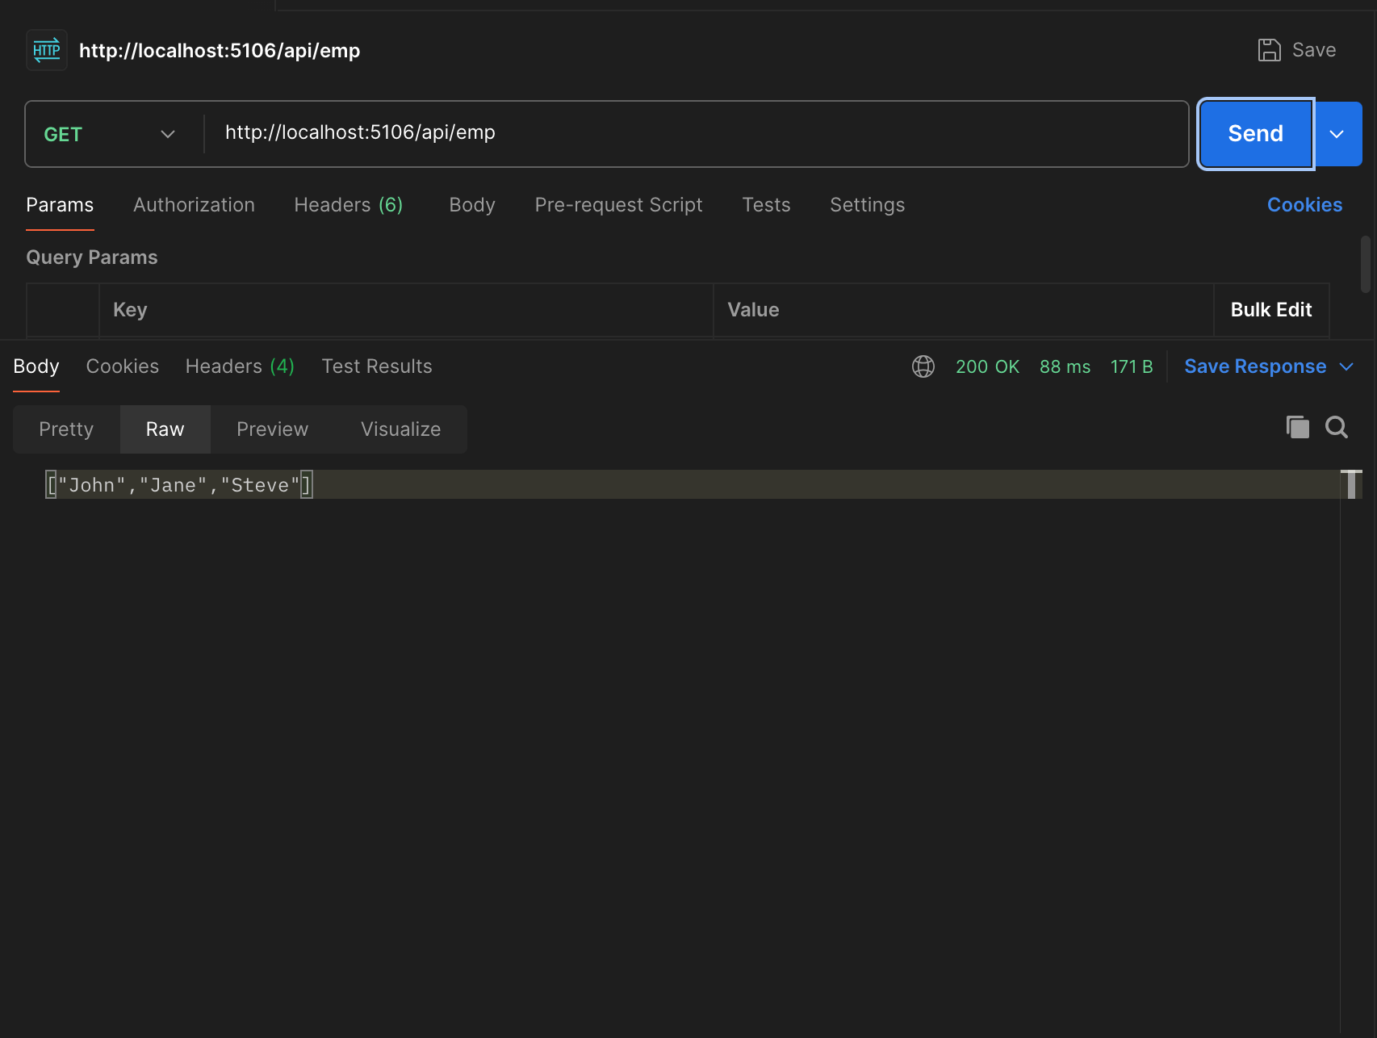

**http://localhost:5106/api/emp**

